Enrolment Form
Complying Written Arrangement for Child Care Subsidy
Dear families,
Please confirm acceptance of the following items so that our Service can receive Child Care funding on your behalf and reduce your fees.
Parties to the Agreement
Between
Parent Name
Address
And
Tralee Gardens Centre for Babies and Toddlers
Tralee Gardens Preschool
Boumansour Nominee Pty Ltd
ABN: 19203 652 69
For the Care of
Child’s Name
Date of Birth
Address of the Child
Start Date
Child’s CRN Number
Gender Male/Female
Place of Birth
Ethnicity/Religion
Languages Spoken
By
Tralee Gardens Centre for Babies and Toddlers
Tralee Gardens Preschool
10 Fryer Ave & 125 Wentworth Ave
Wentworthville NSW 2145
Phone: (02) 9688 3687
M: 0449 663 687
Email: admin@traleegardens.net.au
Routine/ongoing care
Day | Care Required (tick) | Session start  (Drop off time) | Session end  (Pick up time) | Fee | Unit
Monday |  | : am | : pm | refer fee schedule | Session
Tuesday |  | : am | : pm | refer fee schedule | Session
Wednesday |  | : am | : pm | refer fee schedule | Session
Thursday |  | : am | : pm | refer fee schedule | Session
Friday |  | : am | : pm | refer fee schedule | Session
Casual/flexible care
Day | Fee | Unit
 | refer fee schedule | Session

Session (Please tick the session you wish to enrol your child)
7-6
8-6
9-4 (Toddlers & Preschool only)

I confirm:
- the details I have provided above are true and correct
- I have agreed to the days of care and the start and end times of these sessions
- care may be provided on a casual or flexible basis where available at the Service in addition to routine care and
- I am liable to pay fees for my child’s care as indicated above and in line with other information the Service makes available to me (such as a Fee Schedule) which are subject to change over time based on advice from the Provider.

Parent/ guardian Signature ________________________________ Date: / /

Please circle the option appropriate to your child:
Is your child:
- At risk of serious abuse or neglect?
- Of a parent or both parents who satisfies the government’s work, training, study test?
- Any other child?
Information about Parents
 | Parent 1 (Mother) | Parent 2 (Father)
Title
First name
Surname
Parent CRN Number
Home address
Home phone number
Mobile number
Ethnicity/Religion
Languages spoken
Marital Status
Date of Birth
Occupation
Work Address
Work Phone
Email Address
Other children at home-Names and ages
Court orders, parenting plan or parenting orders sighted and signed by JP if any
Other comments
Health
Name of the Doctor
Address
Contact Numbers
Does your child regularly visit a specialist?
Does your child have any special medical condition?
Does your child have allergies? Including whether the child has been diagnosed as at risk of anaphylaxis Y/N
Any medical management plan, anaphylaxis medical management plan or risk minimization plan to be followed with respect to a specific healthcare need, medical condition, or allergy? Y/N
Does your child take any regular medicine?
Has your child been immunized? Y/N
Must provide a copy of the immunization history statement
Medicare number
Health fund

Dietary needs
Does your child have any special dietary needs requirement? E.g., vegetarian
Any food likes/dislikes
Any food allergies
If your child has food allergies, we require an action plan. Please refer to our medical conditions policy at the end of this booklet.
Emergency contacts (please do not include parent’s names)
I authorize the educator of this centre to give the following emergency contact names access to my child/ren (note: must be over 18 years). Please ensure the emergency contact persons are willing and able to collect your child/ren in the event of an emergency. At least two contacts names must be completed before enrolment commences. I authorize the emergency contacts to consent to the medical treatment of, or to authorize administration of medication to the child and any person who is nominated to authorize an educator to take the child outside the education and care service premises. Any person who is authorised to authorise the education and care service to transport the child or arrange transportation of the child.
 | Emergency Contact 1 | Emergency Contact 2 | Emergency Contact 3
First name

Surname

Address

Mobile
Business name

Address

Work Phone
Relation to child

The educator will not allow your child/ren to go with adults unless names are written on this form. If the parents or the emergency contact listed cannot be reached I, ……………………………………………. (Name)
- have given written authorization for the service to seek urgent medical, dental or hospital treatment and ambulance service.
- have given written consent for the carrying out of appropriate medical, dental or hospital treatment to take place.
- If an ambulance is required to attend to my child, I understand that I will be liable for all costs involved.
- I give authorization for my child to get in an ambulance in case of an emergency.

Signature: ……………………………………………

I give permission for:
- My child being observed for student teacher visits.
- My child’s photography and name being used for in- house centre displays.
- My child’s photograph will be uploaded on Kinderloop where it could be visible to other parents.
- My child’s photograph will be uploaded on Tralee gardens Facebook and/or Instagram.
- My child’s photograph taken by educators during special occasions such as Christmas party, birthdays and portfolios and be put on Facebook and Kinderloop.
- The centre will not take responsibility for the distribution or use of any photos/videos taken by anyone other than educators.
- Educators to apply 30+ sunscreen on my child.
- Panadol to be administered to my child in the event of fever (Temperature above 38 degrees) after I have been contacted by phone.
- If parents cannot be contacted, I give permission for single dose of paracetamol (age-appropriate dose) to be administered to my child if their temperature is above 38 degrees.
- Dettol solution, Savlon cream, Sorbelene, Antiseptic spray, QV cream or the nappy rash cream (Sudocream, Bepanthen, Zinc & Castor oil cream) to be applied to my child at the discretion of educator in the event of minor accident.
- Aerogard or Off! (Insect repellent to be applied if we feel children need it whether they are outdoor or indoor depending on weather.
- Information relating to any special dietary requirements of my child, including food allergies to be displayed appropriate for educators’ awareness.
- Contact information including names, addresses and phone numbers being available in a folder for educators’ awareness. Information will not be given or passed to another parties. It is strictly for emergencies. All children files are safely secured in a file cabinet. All files will be stored away when the child leaves the centre till the child turns 25 years of age.
- During an emergency if my child requires the centre’s Ventolin, mask, spacer, or EpiPen, I will pay for the cost of Ventolin, spacer, mask and EpiPen.
- If my child displays signs of allergies educators can administer Zyrtec to relief the allergy symptoms
- We sometimes invite entertainment to the centre. Parents will be given information and notified of the charges prior to the entertainment.
- My child to be taken to the preschool for the entertainment, incursions and play sessions.
- My child from babies and toddlers will be taken to the preschool to practice the emergency evacuation drill.
- Tralee Gardens has CCTV (surveillance cameras) in and around the premises. The purpose of the surveillance is to ensure the safety and security of employees, children, visitors, and property. The employer reserves the right to review and use the CCTV in case of accidents/incidents. All cameras are visible and will not be in change rooms or bathrooms. CCTV cameras will record footage continuously for an ongoing period and the footage will be kept for 2 weeks. Tralee Gardens management has access to the footage and will only share it with employees, parents, visitors, the police, legal representatives in the event of a court case. The footage will automatically be deleted in 2 weeks. The recording is vision but not sound. A copy of the policy is attached to this information booklet.

I have read the relevant centre policies and I agree to abide by it. A copy of these policies is found in the policy manual next to the sign in roll. Some policies are attached to this information booklet.

Parent Name: ………………………………………………………………

Parent Signature: ……………………………………………………….

Date: ……………………………………………………………………………

Enrolment Checklist |  |  | 
Element 6.1.1 | Engagement with the service. Families are supported from enrolment to be involved in the service and contribute to service decisions.
Nominated Supervisor’s Name |  | Date:
Nominated Supervisor’s Signature:
Child’s Name:
 |  |  |  | YES | N/A
All parts of the Enrolment Form completed and signed
Parents 1, 2 and 3 DOB and CRN provided
Child’s DOB and CRN provided
Complying Written Arrangement template signed by parent
Enrolment lodged with Centrelink
Child’s Birth Certificate or equivalent sighted
Court/parenting orders, parenting plans outlining powers, duties, responsibilities in relation to the child provided
Information about the child’s family is obtained e.g., culture, religion, family structure (e.g., siblings, grandparents)
Information about any special dietary requirements/restrictions or additional needs obtained
Information about the child’s interests and strengths obtained
Evidence of immunisation status provided (child fully immunised or has appropriate exemptions – refer Immunisation Policy)
All authorisations and indemnities signed including authority for:
- medical treatment from a medical practitioner, hospital, or ambulance service
- ambulance transportation
- incursions
- regular excursions- Authorisation for ongoing excursions to the preschool room consent signed
- Authorised nominees
- Emergency contacts
- Persons authorised to consent to medical treatment or administration of medication (could be same as authorised nominees/emergency contacts)
Relevant health information is provided including:
- medical practitioner or medical service
- Medicare number
- dental practitioner or service
- healthcare needs, medical conditions, allergies, anaphylaxis, or risk of anaphylaxis
- Medical Management Plan and Medical Risk Minimisation Plan for specific health care need, medical condition, allergy, or anaphylaxis
- Parent Information Pack discussed
- Families provided with copies of, or access to, all policies and procedures, Code of Conduct and Statement of Philosophy
- Medical Conditions Policy provided to all parents where child has a specific health care need, medical condition, allergy, or other relevant medical condition
- Relevant policies and procedures discussed/explained including:
- Medical conditions policy
Child cannot attend without medication
- Administration of Mediation Policy
Medication must be in original container.
Over the counter medications not administered unless prescribed by doctor
Administration of medication must be authorised in writing unless emergency.
Procedures during medical emergency, including asthma and anaphylaxis
- Delivery and Collection of Children Policy
Sign in/out procedure explained.
Procedure if parent running late to collect child
- Grievance Policy
Location of complaint forms
- Fee Policy
Fees should be paid on time. Fees in arrears attract extra charges
- Photography Policy (authorisation signed)
- Infectious Disease Policy
Any child who is unwell must not attend the Service.
Children who become unwell at the Service need to be collected.
If service suspects child has infectious disease, child may be excluded until child has a medical certificate stating they are not contagious.
- Immunisation and Disease prevention Policy
Any child that is not fully immunised may be excluded if there is a vaccine preventable disease at the service
- Sleep, Rest, Relaxation and Clothing Policy
Service implements safe sleeping practices as recommended by SidsandKids.
Sleep and rest practices
Children should wear comfortable clothing that can get dirty.
All items should be labelled with child’s name
- Behaviour Guidance (Relationships with Children Policy)
- Parents will:
- work in partnership with educators to minimise risk where the child’s behaviour is a danger to children and educators.
- consent in writing where educators believe liaising with relevant professionals will support the learning and development of their child
- Health, Hygiene and Safe Food Policy
Service has a ‘healthy’ eating policy.
Service does not allow e.g. nuts into the service
- Tobacco, Drug and Alcohol Policy
No smoking on premises allowed including car park
- Parental Interaction and Involvement in the Service Policy
Family input procedures e.g., “what did you do on the weekend” sheets
- Environmental Sustainability Policy
Measures taken to promote sustainability e.g., litter-less lunches
- Sick children policy, COVID policy and infectious disease policy explained
- Bond and Administration Fee paid in full
- Explained sign in procedure – Temperature check, sanitise, gloves
- Direct Debit form completed/method of payment for fees established
- Tour of service and introduction to educators
- Provide mobile numbers

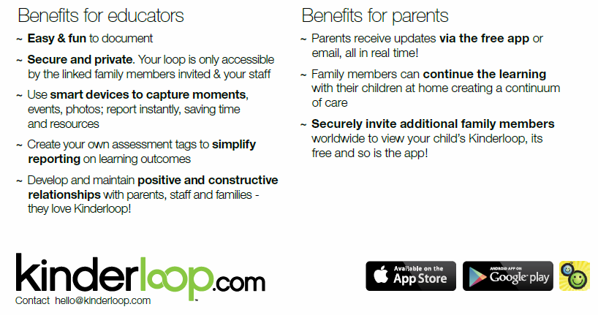
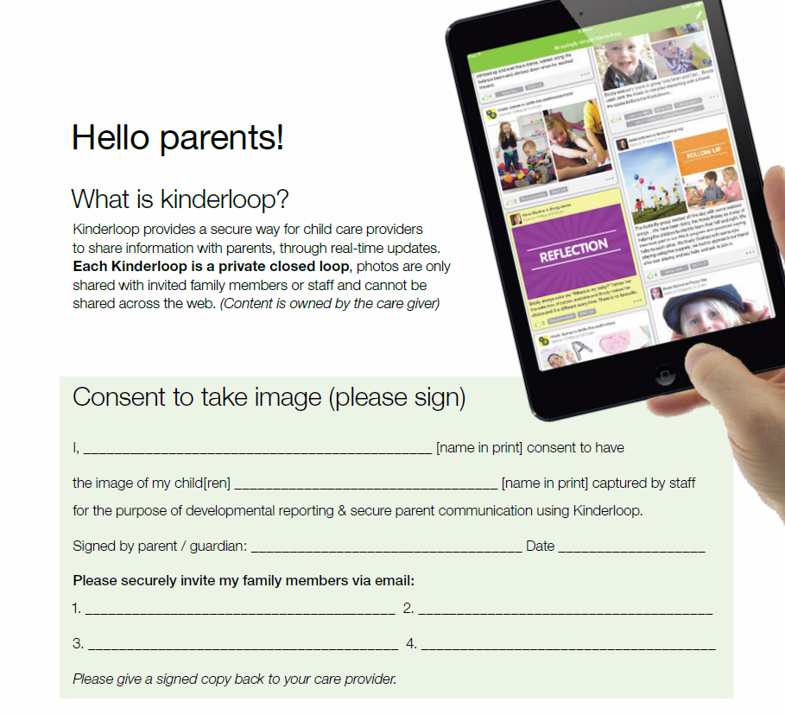

Child Profile Form

Child’s Name: …………………………………………………

Date of Birth: …………………………………………………

Days Attending Tralee Gardens: ………………………………………………………

Family background and Languages spoken: ………………………………………………………

Family Members child has contact with: …………………………………………………………

Do you have pets at home? ………………………………………………………………………

Are there any cultural practices at home that may affect your child’s reaction to experiences in the service? ……………………………………………………………………………………………………

Do you have any multicultural toys or resources (e.g., fabric, CD’s, musical instruments) that you could lend us in the service? …………………………………………………………………………………..

Does your child have any special needs/Medical history/ specialist intervention? ……………………………………………………………………………………………………..
Toileting requirements/attitude to toilet training……………………………………………………………………………………………………………

Sleep/ rest routines/comfort items………………………………………………………………………

Eating habits/food preferences…………………………………………………………………………

Special diet details/reason (e.g., religious/ allergies)
…………………………………………………………………………………………………………………

Babies only (0-2years)
Diet (circle/tick if suited for your child)
Chicken  Eggs  Lamb | - Jelly  - Custard  - Yoghurt  - Cakes | - Puree  - Mashed  - Solid  - Other

Feeds/Bottle
……………………………………………………………………………………………………………..
Are there any special considerations we should know regarding your child’s clothing or dressing procedures?
………………………………………………………………………………………………………………..
We recognise that children learn effectively when opportunities are based on a child’s interests or curiosity. What are your child’s current interests, dislikes, favourite toys &activities? Please share with us special family occasions.
…………………………………………………………………………………………………………………
What are your expectations/ focus for your child whilst attending the childcare?
………………………………………………………………………………………………………………..

What information would you like to receive from your child’s educator and how often?
………………………………………………………………………………………………………………
How can we support your child during their settling in phase at the preschool? (e.g., key words in home language)
……………………………………………………………………………………………………………..
Do you have any menu suggestions (including multi-cultural menu ideas)?
………………………………………………………………………………………………………………
Please read our behaviour management policy. If there are any differences between the strategies used at the centre& those at the service and those used at home, please share it with us.
………………………………………………………………………………………………………………
We invite you to contribute to the program at the service in an ongoing way via the parent communication folder and parent weekend sheet. If you can come in and share an aspect of your culture with the children e.g., read a story in another language, or share an aspect of your aspect of your occupation (e.g., any fireman, policemen or musicians) we would love to organise this with you at a time to best suit you.

This type of experience greatly enriches the program at the preschool. Please indicate if you would be interested.
…………………………………………………………………………………………………………………..
At Tralee gardens we aim to respectfully understand celebrations and special occasions that are celebrated by families from other cultures. E.g., Chinese New Year, Christmas. Our community has many cultures within it, and so we aim to increase children’s understanding and tolerance of difference cultures by not concentrating on celebrations exclusive to one culture.
If your family participates in cultural celebrations, please share the details with us.
………………………………………………………………………………………………………………….
Please share with us your thoughts on ‘Santa Claus’ and ‘Christmas celebration’. Do you celebrate Christmas at home? How can we make Christmas more meaningful to young children?
……………………………………………………………………………………………………………………
Please read the centre philosophy, contained in information booklet. We review our philosophy annually and you are encouraged to raise issues about our philosophy at any time with management or educators. Please comment on our philosophy
…………………………………………………………………………………………………………………….
Are you aware we have policies & procedures for the running of day and policies that relate to your child’s protection? This manual is in the foyer in each area … please read it!
……………………………………………………………………………………………………………………..

Evaluation of Orientation Process
Checklist
At Tralee Gardens we always aim to make all transitions as smooth as possible. Your feedback on how you felt this orientation process went is extremely appreciated and we value your input.
What influenced you to contact Tralee Gardens Centre to enrol your child? Where did you hear about our centre?
…………………………………………………………………………
During the orientation process did responsible person: (Please tick below)
- Introduced you to the educators.
- Showed you where to sign your child in and out?
- Showed you where to put your child’s belongings?
- Informed about the fee structure and how to pay?
- Explained the centre’s menu and showed you where it is displayed?
- Informed you about the centre’s operating hours?
- Explained that late fees applies if you are late to pick up your child.
- Showed you where the centre’s Policy and Procedure Manual is kept
- Explained how you can make an input in the centre’s program.
- Showed where the child pocket will be. This is where receipts and newsletters are placed.

How can we improve our orientation process?
…………………………………………………………………………

Babies Routine
7am | Parents wash their child’s hands on arrival.  0-2 Room and 2-3 Room are combined.  Spontaneous experiences in Elephant Room (back playroom)
8am | 2-3’s children move to their Room.  Nappy change & hand washing  Singing and story time
8:50am | Tidying up time with pack away music
9am | Morning Tea (see menu)
9:30am | Milk and water offered
9:30am-11:20am | Sunscreen applied for outdoor play (weather permitting)  Outdoor play spontaneous experiences in undercover area for babies
9:30am-10:30am | Pre-walker sleep (if needed)
10:30am | Nappy change & handwashing.
11:20-11:30am | Tidying up time with pack away music
11:30am-12pm | Lunch and Dessert, water offered
12:00pm | Wipe faces.  Sleep/ quiet activities
1:00pm | Children begin to wake up.  Separate into groups/ spontaneous activities
1:40pm | Milk offered
2:00pm | Pack away rooms  Sit children on mat for group time.  Munch and Move (Music and movement)  Nappy change, hand washing
3:00pm | Afternoon Tea
3:30pm | Remain in focus groups.  Spontaneous indoor/outdoor play weather permitting/sunscreen applied
4pm | Nappy change, hand washing  Spontaneous play continues
4:55pm | Pack away rooms  Combine children in Elephant Room (back room)
5:00pm | Quiet play
5:40pm | Pack away room
6pm | Centre closes

Toddlers Routine
7.00 – 8 am SPONTANEOUS INDOOR ACTIVITIES | Children meet in the 0-2 room engaging in quiet, indoor experiences,  Hand washing upon arrival
8.00 – 8.30 am INDOOR/OUTDOOR EXPERIENCES | Move to the 2-3 room.  Spontaneous Indoor/outdoor experiences based on children’s interest, strength, and family Input.
8.30-9 am Munch and Move | Munch & Move is NSW Health initiative that supports the healthy development of children birth to 5 years by promoting physical activity, healthy eating, and reduced screen time.
9.00-9.30 am STORY TIME | Story time followed Progressive toileting and nappy change time.
9.30am -10.00 am PROGRESSIVE MORNING TEA | Progressive Morning Tea (See Menu)
10.00am-10.30am GROUP TIME | Children separate into their focus groups for group time.  Group time followed by spontaneous play.  Focusing on Intentional Teaching on Pre-Numeracy and Pre-Literacy Skills
10.30-11 am OUTDOOR PLAY /INDOOR PLAY | Outdoor Play (weather permitting).
11.00 am TOILET/NAPPY CHANGE | Toileting and nappy change: Spontaneous indoor or outdoor play (weather permitting)
11.45 am - 12.00pm Lunch | Two groups indoors and two groups using the undercover area to have lunch
12pm - 12.15 pm | Children have their faces and hands wiped. Proceed to beds followed by toileting and nappies on for rest time, if required
12.15pm-2.15 pm SLEEP/ RELAXATION TIME | Children patted to sleep or provided quiet experiences
2.15 pm PROGRESSIVE NAPPY / TOILET TIME | Children are assisted in the toilet and nappy change time
2.15pm - 3.00pm STORY AND SINGING | Children sit on the mat and read stories
3.00pm - 3.30 pm PROGRESSIVE AFTERNOON TEA | Children have afternoon tea in the undercover area or inside weather permitting.
3.30pm - 4.30pm SPONTANEOUS INDOOR/ OUTDOOR PLAY | Children engage in spontaneous Indoor/outdoor play
4.30pm - 5pm STORY TIME | Story time followed by late evening snacks
5pm-6pm QUIET ACTIVITIES | Quiet indoor activities: These activities include, Munch and Move exercise/relaxation experience e.g., yoga, meditation.
6.00pm | Centre closes

PRESCHOOL ROUTINE
7.00-8.00 | Quiet indoor activities  Experiences are set based on the children’s interest, family input or intentional teaching. Parents to apply sunscreen to their child which is available in the hat room
8.00-8.45 | Outdoor/Indoor activities (weather permitting)  Children proceed outdoors and often select then assist in the setting up of activities. Sunscreen is applied and children engage in spontaneous play.
8.45-9.00 | Story time and singing
9:00-9.25 | Exercise (Munch and Move Fundamental movements)
9.25-9.30 | Transition to smaller groups
10:00-10.30 | Morning Tea  Children transition to the toilets for hand washing and proceed to morning tea Morning tea variety of fresh fruits and vegetables is offered with milk or water (see menu)
10.00-10.45 | Group time  Children will be engaged in a variety of experiences based on their interest, family input or intentional teaching e.g. news time, arts and craft, cooking or sensory experiences
10.45-11.45 | Literacy experiences and Numeracy experiences  Children engaged in writing/tracing/copying/drawing or alphabet/number recognition games
11.45-12.00 | Yoga and stretches
12.00-12.45 | Lunch  Children transition to the toilets to wash their hand ready for lunch. Variety of healthy hot meals provided (see menu)
12.45-3.00 | Sleep/rest time  Children are patted to sleep or are encouraged to rest listening to tape stories or relaxation music
2.45-3.15 | Story and singing
3.15-4.00 | Progressive afternoon tea  Children are transitioned to the toilets for hand washing. A variety of fruits and vegetables is provided with milk or water (see menu)
4.00-4.45 | Indoor/Outdoor activities (weather permitting)  Children engage in spontaneous experiences outdoors/indoors depending on the weather
4.45-5.00 | Pack away time  Children assist in packing away outdoors and proceed indoors with educators
5.00-6.00 | Quiet experiences indoors  Children are engaged in singing, stories or quiet activities
6.00 | Centre closes

NSW Department of Education

2024 Declaration and consent form
2024 Start Strong for Long Day Care
Families with children who are at least 4 years old on or before 31 July 2024 (the child’s birthdate must be on, or before, 31 July 2020), and are enrolled at an eligible long day care service may save up to $2,110 in 2024.
Families with children who are 3 years old and not yet 4 years old on, or before 31 July in 2024 (the child’s birthdate must be on, or between, 1 August 2020 and 31 July 2021), and are enrolled at an eligible long day care service may save up to $500 in 2024.
It’s important you complete this form for your service to apply fee relief to your invoices and to provide consent for your service to share personal information with the department.
You are required to complete this form for each service your child attends to receive fee relief at any service. If you do not provide this information, the early childhood education service cannot assess your child’s eligibility and cannot provide you with fee relief.
- Please complete this 2024 Declaration and consent form.
- Please complete a separate form for each eligible child in your family enrolled at this service.
- You can only access fee relief at one service at any one time for each child.

Child details
First name
Last name
Sex
Date of birth
Your child must be at least 3 years old on, or before, 31 July 2024
Address
Where your child primarily resides (this should not be a PO Box address)
Aboriginal and/or Torres Strait Islander | Has your child been identified on their enrolment form as Aboriginal and/or Torres Strait Islander?  Yes No
Language other than English | Does your child have a Language Background Other Than English (LBOTE) including Australian Sign Language (Auslan) or Aboriginal language, or does your child's parents or primary care givers speak another language (even if the child speaks English)?  Yes No

Early childhood education service details
Service name
Service address

Other service/s your child is enrolled
Is your child enrolled at another community preschool or long day care?
Yes No
If you answered ‘yes’, please provide the name/s of the other service/s

PARENT/CARER/GUARDIAN DECLARATION
I consent to this information about my child being collected on behalf of the NSW Department of Education in accordance with the privacy notice below.
I consent to the disclosure of this information about my child by the early childhood education service listed above to the NSW Department of Education and other State, Territory or Australian Government bodies, as per the Privacy Notice.
Please tick the box for fee relief option that applies to you:
I want to access fee relief at (insert service name)
OR
I do not want to access fee relief at (insert service name) as my child is receiving Start Strong fee relief from another community preschool or long day care service.

Parent/carer/guardian details
Name
Signature
Date

Privacy Notice
The personal information provided to the early childhood education service in accordance with this declaration is being collected by NSW Department of Education (“we” and “us”). This information is required to assess eligibility and provide fee relief. If you do not provide the information as part of this form, the early childhood education service cannot assess your child’s eligibility and cannot provide you with fee relief.

We are collecting this personal information about you and your child in connection with the administration of the Start Strong for Long Day Care program (“the program”) including (but not limited to) assessing eligibility, managing payments, auditing compliance and evaluating the program.
We may share this personal information with Services Australia and the Australian Government Department of Education, who may use it in connection with childcare funding, policy development and compliance, and disclose it to other State, Territory or Australian Government bodies.
Otherwise, we will not use or share this personal information unless permitted by law.
The NSW Department of Education Privacy Information, Australian Government Department of Education, and Services Australia’s Privacy Policies can be accessed at:
- NSW Department of Education Privacy Information and Forms
- Australian Government Department of Education Privacy Policy or by email privacy@education.gov.au
- Services Australia Privacy Policy or by phone 1800 132 468
These privacy policies contain information about how to make a complaint, and how to access and correct your personal information.
Privacy Policy links
- https://education.nsw.gov.au/about-us/rights-and-accountability/privacy/privacy-information- and-forms
- https://www.education.gov.au/using-site/privacy-statement-department-education
- https://www.servicesaustralia.gov.au/privacy-policy?context=1

Office use only (to be completed by the early childhood education service)
Child enrolment ID | Child is eligible for 4YO+ Fee Relief Payment (the child’s birthdate must be on, or before, 31 July 2020).  OR  Child is eligible for 3YO Fee Relief Payment (the child’s birthdate must be on, or between, 1 August 2020 and 31 July 2021),
Fee relief eligibility

Service ID
Staff name
Signature
Date

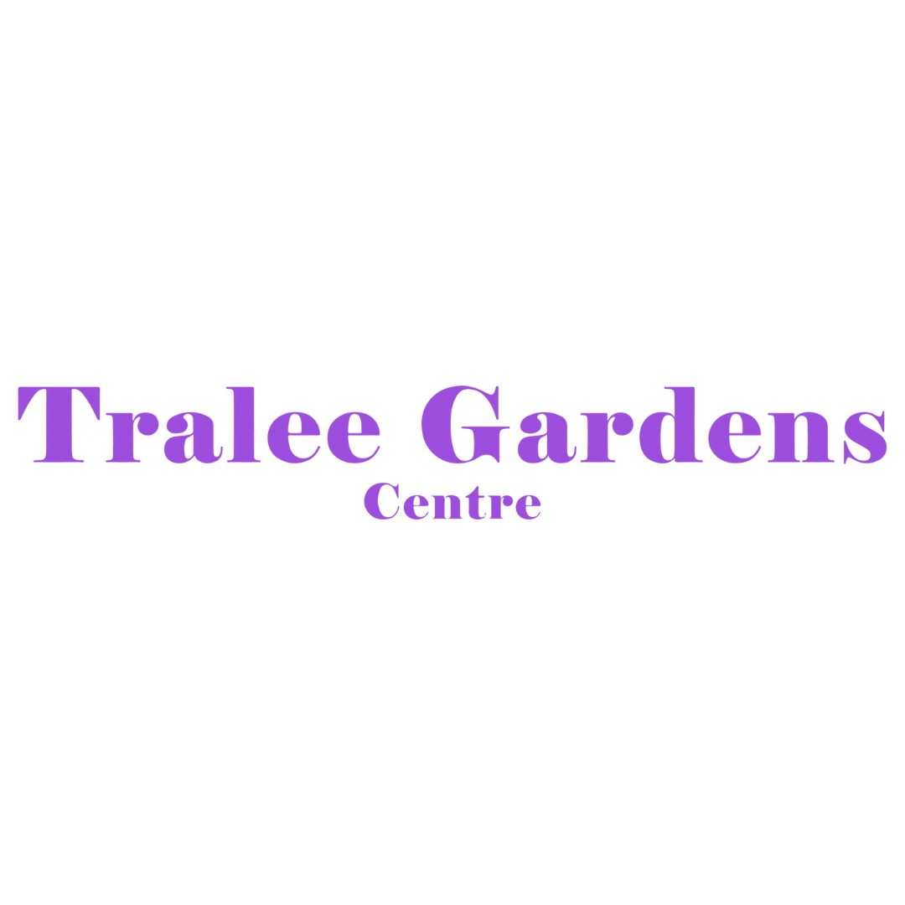
Authorization for ongoing excursions to the preschool room OR from preschool to the car park
Date from……………………. to…………………………….
Under the Education and Care Services National Regulations, written authorization must be given by a parent or guardian to permit their child/children to participate in excursions. A regular excursion is defined as one which the educator does regularly as part of her educational program and where the circumstances relevant to the risk assessment are substantially the same on each outing. The authorization is valid for 12 months unless the educator makes changes to the excursion and/or management plan. If this occurs, then parents are required to consent to the changes in writing. Each non-routine excursion will require a separate risk management plan and permission form.
Child’s Name
The reason the child is to be taken outside the premises. | Excursions  Practicing emergency drills  Orientations
If the authorization is for a regular outing, a description of when the child is to be taken on the regular outings. | Children from babies and toddlers will be taken to the preschool for regular excursions, orientations and to practice emergency drills point A  Children from preschool will be taken to the carpark to practice the emergency drill using point B
The proposed pick/up location and destination | Babies and Toddlers  Preschool
A description of the proposed destination for the excursion | Babies and toddlers to Preschool  Preschool or the carpark
Proposed method of transport, i.e., walk, travel by bus or be transported in the educator’s vehicle. | Walking
The proposed activities to be undertaken by the child during the excursion. | Excursion  Orientation  Practicing emergency drills
The period the child will be away from the premises. | Depends on the shows and events (information will be posted on Kinderloop)
The anticipated number of children likely to be attending the excursion.  The anticipated ratio of educators attending the excursion to the anticipated number of children attending the excursion. | Toddler ratio 1:5  Babies ratios 1:4  Preschool ratios 1: 10
The anticipated number of staff members and any other adults who will accompany and supervise the children on the excursion. | Will depend on the number of children on the day.
A risk assessment has been prepared and is available at the service. | Yes
I have read and understood the educator’s excursion and transport policies, including the risk/benefit assessment for each excursion.
I agree to my child/children being taken on the excursion as described above:
Parent Name
Parent Signature
Date

